Women Empowerment

1. **Enterprises Set-up**; (Specify the population of village) This indicator is mandatory without filling this Form should not submitted.



1. **Enterprises Set-up**: This Should be Compulsory.
2. **Enterprises Set-up**: This Should be Compulsory.A screenshot of a computer

   Description automatically generated
3. **Enterprises Set-up**: If I select No in this first indicator then second indicator should be disable.

1. **Enterprises Set-up**: This Should be Compulsory.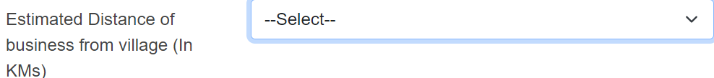
2. **Enterprises Set-up**: This Should be Compulsory.



1. **Enterprises Set-up** ( Do you Require any advanced support for your Business ) If I select No in this indicator then next two indicator should be disable.

